44.51: a)
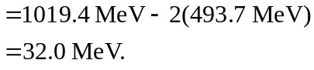
Each kaon gets half the energy so the kinetic energy of the 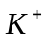is 16.0 MeV.
b) Since the 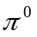mass is greater than the energy left over in part (a), it could not have been produced in addition to the kaons.
c) Conservation of strangeness will not allow 